Dharmendrasinhji Arts College, Rajkot
Dr. Yagnik Road, Ph./Fax No. (0281) – 2465632
Govt. Of Gujarat
(Affiliated with Saurashtra University)

7.1.6 Beyond the campus environmental promotional activities

Report of Tree Plantation
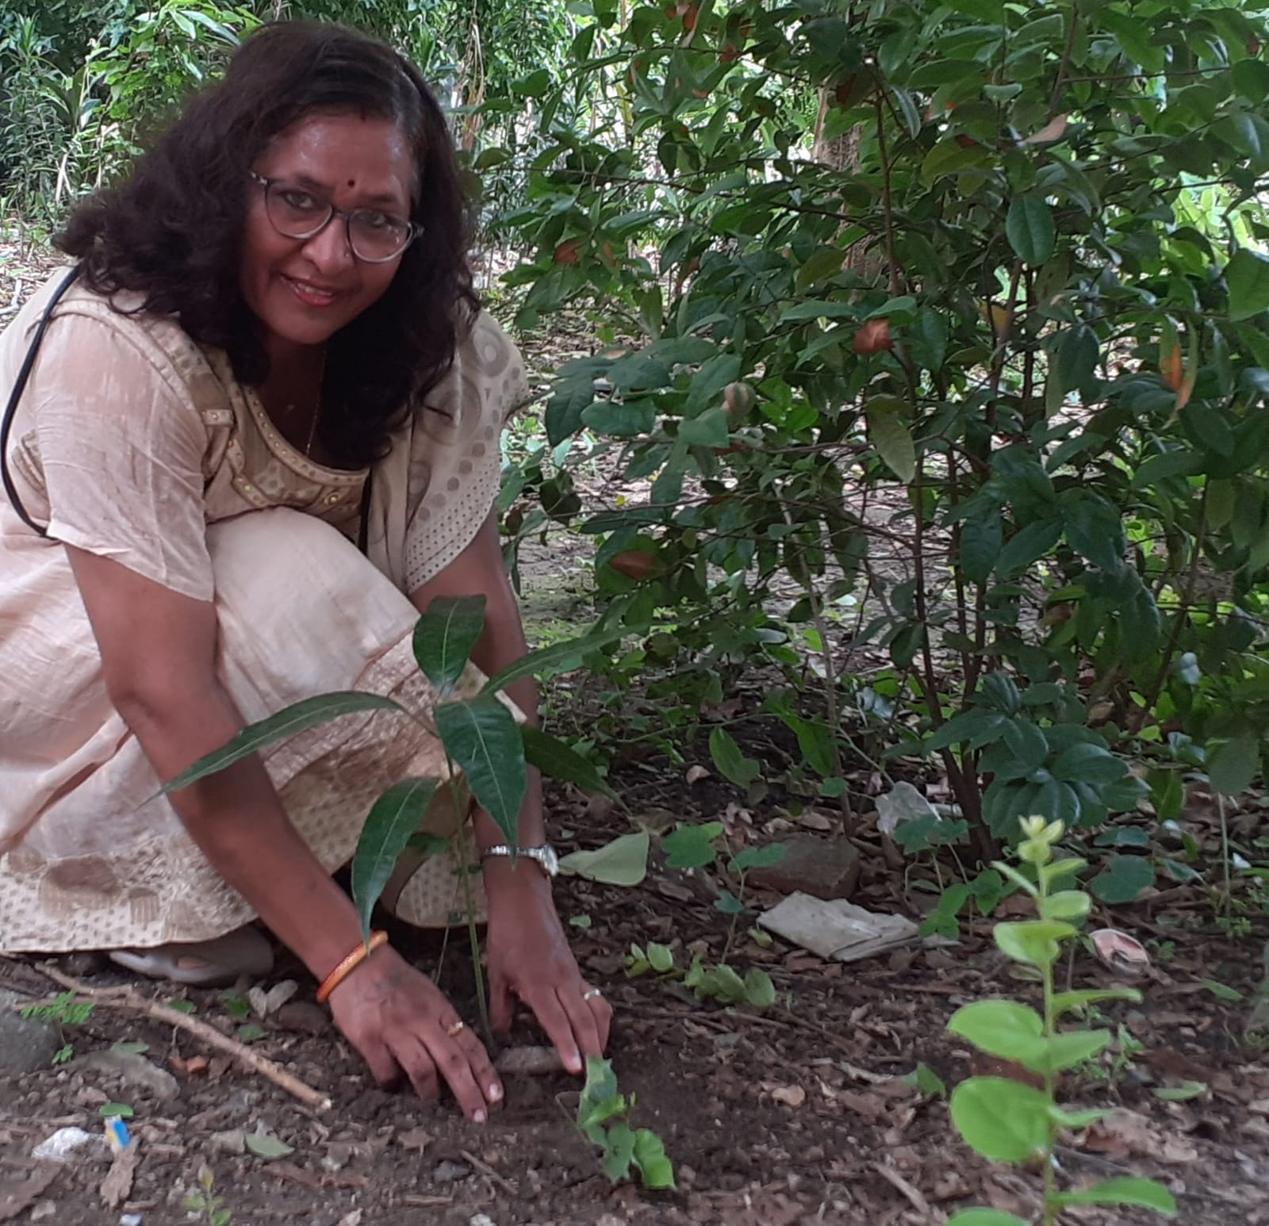
“Ek Ped Maa Ke Naam” On 13th August 2024, Dr. Hansa Gujariya, an assistant professor and Students from the Institute participated in Tree Plantation Activities at Botanical Garden of Kotak Science College, Rajkot. There were many trees planted during the whole plantation programme.
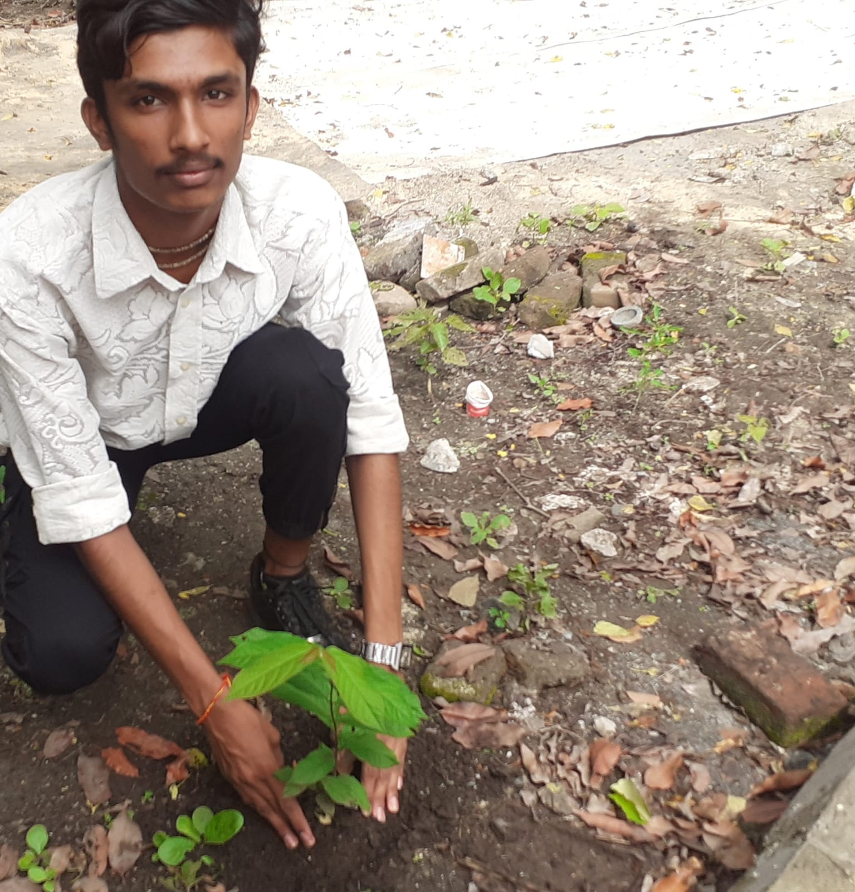

Educational Tour - Bhichhari Hills and Pradyuman Park Zoo – Rajkot:
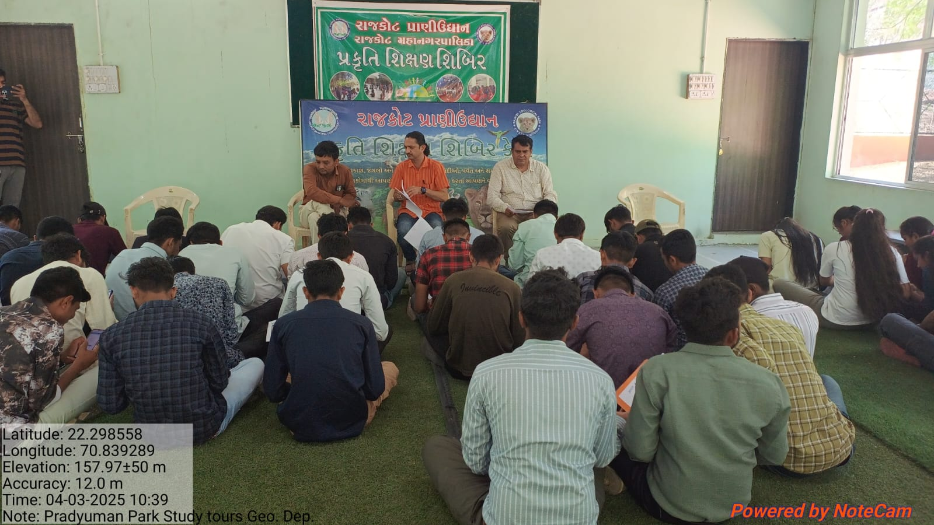
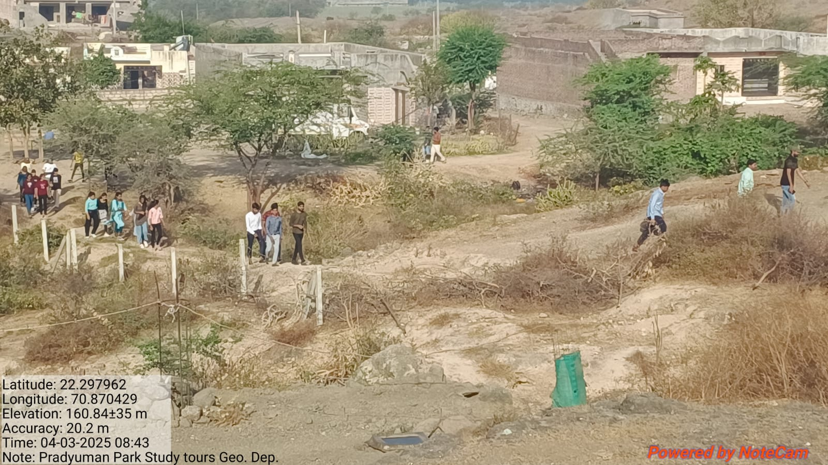
Zoo visits provide experiential learning about animals, ecosystems, and conservation. When students see animals up close, they: Develop empathy for wildlife, learn about endangered species and their habitats, Understand the impact of human activity on biodiversity.
